The instrumentation part of this design consists of the electronics that actually record data. This is distinct from the framework that structurally supports everything, and the optional protection to prevent animal damage.

Data logger

Sensor1

Sensor2

Sensor3

The core of the instrumentation is a data logger. In the most general terms, a "data logger" is a device that records measurements over time.

A logger has one or more "sensors", the parts that actually take the readings. The logger stores the measurements internally.

|  |  |  |  |
| --- | --- | --- | --- |
| Example data | | | |
| Time | Sens1 | Sens2 | Sens3 |
| 1:00 | 4.10 | 71.9 | 0.09 |
| 2:00 | 4.11 | 71.8 | 0.10 |
| 3:00 | 3.99 | 72.3 | 0.11 |
| 4:00 | 4.01 | 72.1 | 0.13 |

Later, you connect the logger to a computer and copy out the data. The data set is delivered in some sort of tabular format that associates each sensor reading with the time it was taken.

In our design, the logger is the HOBO model "U30-NRC", by Onset Computer Corporation. This is a type used for outdoor weather stations.

http://www.onsetcomp.com/products/data-loggers/u30-nrc

Although sensors are conceptually part of the logger functionality, the sensors for a U30 are individual plug-and-play components you buy separately. Each sensor has a cable. On one end of the cable is the actual sensing component, such as a light meter. On the other end of the cable is a standardized clip that plugs into the U30.

The core parameter we are interested in is the greenness index, Normalized Difference Vegetation Index (NDVI), discussed fully in the data processing section. There is no direct NDVI sensor available. Instead, NDVI is generated from readings of visible light and near-infrared.

Logger

Visible light

Near-infrared

Core parameters

Irradiance sensors

Plants respond to changes in their environment, so we felt it was important to include other sensors for what we call generally "microclimate" readings. These are soil and air temperature and moisture content.

Logger

Visible light

Near-infrared

Extended parameters

Irradiance sensors

Soil temperature

Soil moisture

Air temperature

Relative humidity

Micro-climate sensors

The temperature sensors for soil and air are similar to each other. However the moisture in soil is liquid, while the moisture in air is vapor, or "relative humidity".

We used sensors that were available from Onset, to directly plug into the U30 data logger.

As an illustration, we will describe one particular deployment of mantises we used on the North Slope of Alaska.

We built 22 mantises total, of two different instrumentation configurations (schematics below). Most (20) of the mantises were of the "station" configuration. "Station" mantises were arrayed in 5 replicates of two different experimental conditions, plus controls. The other configuration was "reference". We made 2 "reference" mantises to track baseline sky irradiance, which we will discuss in the data processing sections.

"Station" configuration

Solar panel

PAR sensor

Solar radiation sensor

Air temperature / relative humidity sensor

Soil temperature sensor 1

Soil temperature sensor 2

Soil moisture sensor 1

Soil moisture sensor 2

Hobo U30 data logger

In both configurations, the Hobo U30 data logger is the heart of the design. Each mantis has a solar panel to keep the logger battery charged.

We used off-the-shelf sensors that were available for this data logger. In this case, the air temperature and humidity functions were combined in one physical sensor. We mounted this at 30 cm height for near-ground data.

Ideally, we would have liked direct "visible" and "infrared" sensors. However, the closest match for "visible" was "Photosynthetically Active Radiation" ("PAR"). For the infrared band, we used a "Solar Radiation" ("SR") sensor, and derived "infrared" by subtracting out the "visible". We explain the derivations, including units conversion, in the data processing section. Both irradiance sensors point down, to record light reflected up from the tundra.

We used two *each* of soil temperature and moisture sensors, as arctic tundra is heterogeneous terrain having dry tussocks with wet hollows in between. One of each type of these sensors was in a tussock, and the other in the space between.

"Reference" configuration

Solar panel

PAR sensor, up-looking

Solar radiation sensor, up-looking

Air temperature / relative humidity sensor, 30 cm height

Hobo U30 data logger

PAR sensor, down-looking

Solar radiation sensor, down-looking

Air temperature / relative humidity sensor, 1 m height

The "reference" configuration has the same standard logger and solar panel as the "station".

We used the same kind of combined temperature/humidity sensors as above, but two of them. We mounted one at the same 30 cm height as for the "station" mantises, and another at 1 m height.

We used two *each* of the PAR and Solar Radiation sensors. One set points down, as in the "station" mantises. The second set points up to monitor the sky.

Instrumentation parts list

|  |  |  |  |  |
| --- | --- | --- | --- | --- |
| Item | Onset part number | Price each (for estimation only, may change) | Number needed for this configuration | |
| "station" | "reference" |
| Data logger | Hobo U30 | $418 | 1 | 1 |
| 6 Watt Solar panel | SOLAR-6W | $164 | 1 | 1 |
| PAR sensor | S-LIA-M003 | $220 | 1 | 2 |
| Solar Radiation sensor | S-LIB-M003 | $210 | 1 | 2 |
| NDVI plate, mount for irradiance sensors | M-NDVI | $20 | 1 | 1 |
| Air temperature / humidity sensor | S-THB-M002 | $189 | 1 | 2 |
| Solar Radiation Shield for temperature / humidity sensor | RS3 | $65 | 1 | 2 |
| Soil temperature sensor | S-TMB-M006 | $105 | 2 | 0 |
| Soil moisture sensor | S-SMC-M005 | $139 | 2 | 0 |

Other than optional cable protection, which we discuss in a separate section, most of the instrumentation assembly is straightforward. You simply plug each sensor cable into the U30 logger, and place the sensor ends where you want them. Details, such as weatherproofing, are well explained in the Onset documentation.

Only a few aspects of the instrumentation need further discussion here:

* Mounting the logger case and solar panel on flat vertical supports rather than round masts.
* Mounting the irradiance sensors and controlling their field of view.

A mantis is functionally a "weather station", but with a framework of steel straps rather than the more usual pole mount. There are a few requirements that need to be satisfied; we did these in a different way than on a pole mount.

* The solar panel should be as high and unobstructed as possible, to gather solar energy.
* The battery in the U30 data logger, and therefore the case itself, must be mounted upright for proper functioning.

The Hobo U30 logger comes with the hardware for mounting it on a round pole.

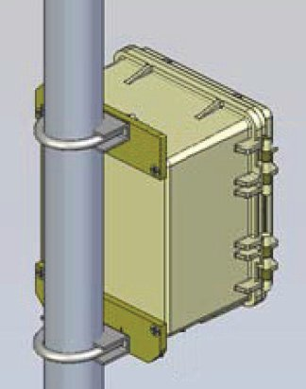  
  
U30 logger case, pole mount  
(image adapted from Onset Computer Corp)

This hardware includes U-bolts (the curved pieces shown encircling the pole), clamps (the pieces shown against the back of the logger), and locknuts (out of view in this illustration, threaded onto the ends of the U-bolts.

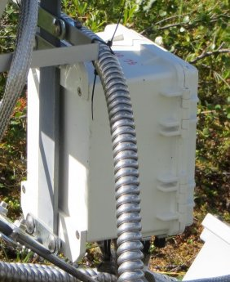  
  
U-30 logger case, strap mount

Since the mantis frame is made of steel straps, we came up with an adaption for mounting the U30 case on these in the upright position required for correct battery operation.

We substituted other parts for the U-bolts, etc. You are welcome to try different hardware, but the following is the simplest way we found.

The key piece is a metal part called a "U-bolt plate". This is Fastenal part number 42082. It is a roughly rectangular strap of metal with two holes. The holes are intended to line up with the legs of a U-bolt, but in this case, we use it as a *substitute* for the U-bolt.

  
U-bolt plate

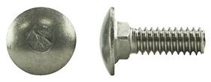  
carriage bolt,  
 top and side views

The other parts that complete the substitution for a U-bolt are "carriage bolts". We used bolts of length 1", which is Fastenal part number 1174430 (package of 50) or 74430 (single) in stainless steel, or part number 1128318 (package of 100) or 28318 (single) in galvanized.

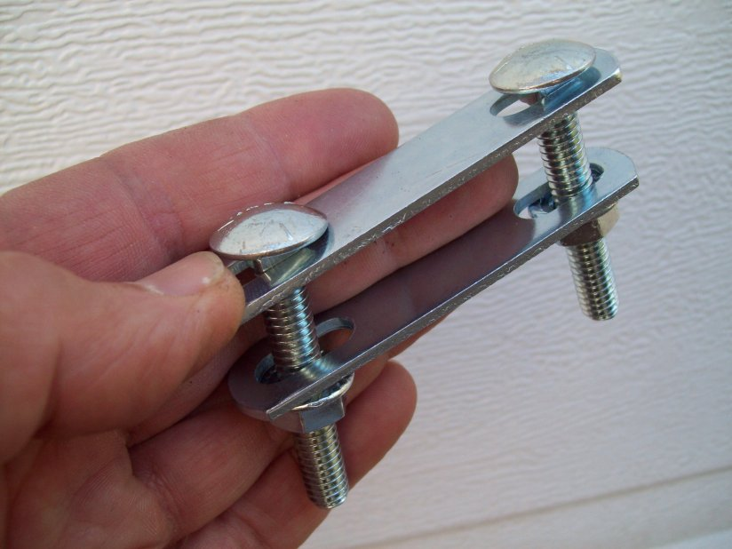  
bolt plate "sandwich"

The square shoulders of carriage bolts drop into the slots of the u-bolt plate and eliminate the need for any lock washers on the head end. We used "sandwiches" like this for assembling parts of the frame (see the frame section). The picture shows somewhat longer carriage bolts than needed for mounting the Hobo U30 logger. When mounting a U30 on a steel strap, the logger itself takes the place of the lower U-bolt plate in the picture above.

Referring back to the previous picture captioned "U30 logger case, strap mount", you can see the sets made up of one U-bolt plate plus two carriage bolts. There is one such set at the top of the logger and one at the bottom. They form "sandwiches" with the U30 plastic mounting plates, which come as part of the complete U30 logger. The "sandwiches" clamp onto the upright steel strap of the mantis frame.

The final parts that complete each "sandwich" are flange locknuts. These have serrations on the bottom, which eliminate the need for separate lock washers. These are Fastenal part number 0129151 if you buy them separately, but four of these come with the U30 for mounting using its U-bolts.

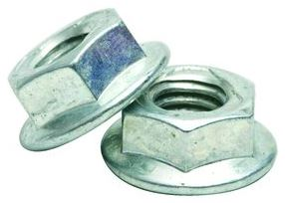  
flange nuts

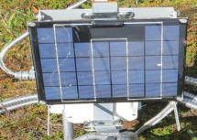  
solar panel, mounted  
 using U-bolt plates

The solar panel comes with U-bolt mounts for clamping it on to a round pole.

As for the U30, we substituted U-bolt plate "sandwiches" to clamp it on to the steel straps.

In use, a mantis is set up with the irradiance sensors (which we will discuss next) facing the equator (south in the northern hemisphere, north in the southern hemisphere), to be as little shaded as possible by the rest of the equipment. The solar panel should also be facing so, to get maximum energy. The datalogger can be facing the other way. This makes it easier for you to access the door when you need to open the logger to download data.

(The white object above the solar panel in this picture is the radiation shield of the temperature/humidity sensor. It is in a slightly different position from the original configuration, which had been on a separate stake at 30 cm height above ground.)

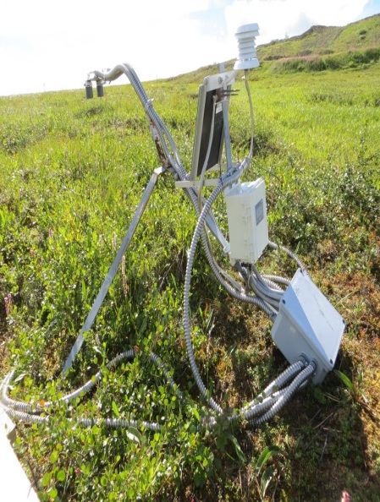  
Mantis, showing solar panel and U30 datalogger

The irradiance sensors are the "business end" of the whole mantis.

  
[close-up of the NDVI plate with sensors mounted]

The picture above is from a "station" logger, where there are two sensors, one for each spectral band, and both are pointing down.

The sensors are mounted on an "NDVI plate" or "NDVI bracket", Onset part number "M-NDVI". We prefer the nomenclature "NDVI plate" to avoid confusion with the Onset "Light Sensor Bracket", part number "M-LBB". Onset's light sensor bracket is intended for mounting a single irradiance sensor on a round mast. It holds the sensor out away from the mast for a less impeded view.

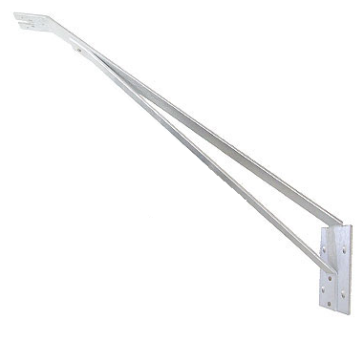  
Onset "M-LBB" light sensor bracket, not used in our design.

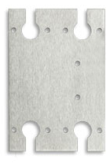  
Onset "M-NDVI" plate.

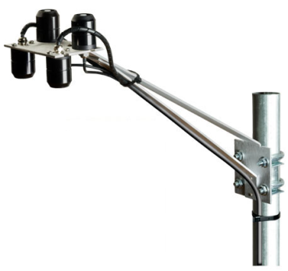  
Onset "M-LBB" light sensor bracket with "M-NDVI" plate and four sensors. Mantis neck substitutes for the bracket in our design.

The NDVI plate is an adapter made to go on the light sensor bracket so a single mount can support up to four irradiance sensors instead of only one.

The "neck" of a mantis essentially replaces the light sensor bracket. We designed the mantis so an NDVI plate goes on the head. The two (in the "station" configuration) or four (in the "reference" configuration) irradiance sensors are mounted on the NDVI plate.

The raw sensors have what is called "cosine response". This means they are most sensitive to light coming straight on from the front. The sensitivity drops off gradually to zero at 90 degrees away from straight-on.



0˚

+90˚

-90˚

Cosine response

0˚

90˚

Sensitivity

We want the sensors' angular sensitivity to drop off faster than "cosine" because we are much more interested in what's directly in front of them (in this case the ground below), than what's off to the sides. In fact, we particularly want to cut out any "hot spots" in their peripheral field of view, such as shine spots from metal, or light colored pieces of equipment like PVC pipe.

0˚

+90˚

-90˚

Collimated cosine response

Sensitivity

0˚

90˚

We do this with "collimators". A basic collimator can be just a sleeve that fits down over the sensor to block its side view.

For practical equipment, the collimators need to be simple, sturdy and reliable. The design we came up with uses [nominal dimension] PVC pipe. The pipe should be dark colored to minimize reflections off the inner surfaces.

  
 [photo of collimator]

We wanted an angle of view that was a cone something like 45 degrees. For various reasons this cannot be exact. However, we empirically determined the length of the collimators should be [mm].

We wanted the collimators to be easily removable, for example to clean out any spider webs or other debris. This is the mount we came up with: The back end of the collimator has four saw cuts in a cross shape. The collimator has an inside diameter of [], so it fits down over an irradiance sensor with outside diameter of [], leaving [] of space in between. Then, the collimator is "pinch fit" on to the sensor using a hose clamp. This squeezes the four "tabs" between the saw cuts tightly against the sensor body.

We used a style of hose clamp that has thumb screws so no tools are needed. This is McMaster part number 5362K16. We also used these same hose clamps for other purposes, as described in the "protection" section.

In setting up mantises, the question often comes up "how far above?" the vegetation the irradiance sensors should be. We believe the more practical way to think of the problems is "what do the sensors see?"



The cutoff angle of a collimator cannot be exactly defined due to the physical extent of the sensor area

As previously mentioned, the collimated sensors have field of view of about 45 degrees. There are various sources of inherent uncertainty. Still, picturing a 45 degree cone projected out from the sensor gives an idea what the sensor "sees".

Vegetation never has a definite "height". Not only does the ground undulate, but individual leaves and stems stick up to various positions.

In practice, we found it useful to picture the cone, and direct it to a region of interest. In heterogeneous terrain, this might be an individual shrub, or patch of grass. Obviously, if one large leaf is sticking up right in front of one of the sensors, that will heavily skew what the sensor sees.

A classic issue in ground surface NDVI is that it is "anisotropic". This means that as you get away from looking straight down from vertical, the vegetation is going to preferentially hide bare spots. From satellites, this factor has more to do with the curvature of the earth. The further away a reading is from looking straight at the center of the earth's disk, the more the angle of the vegetation will hide bare soil. Mantis readings are anisotropic for a different reason. The sensors are so close to the ground there is significant parallax towards the edge of the field of view.

In practice, since you are probably interested in the NDVI trends over time, the main issue is not to mount a mantis so it has bare soil in the center of the field of view.